PostgreSQL with Java

1. Browse to: <http://www.enterprisedb.com/products-services-training/pgdownload#windows>
2. Download the appropriate Installer Version **9.6.1** version for your computer

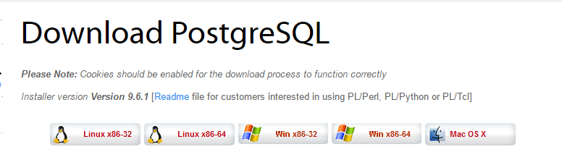

1. Run the installer executable

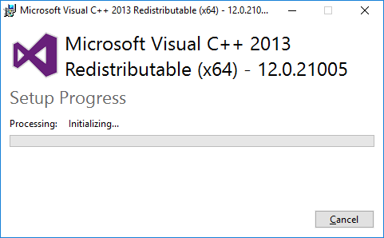

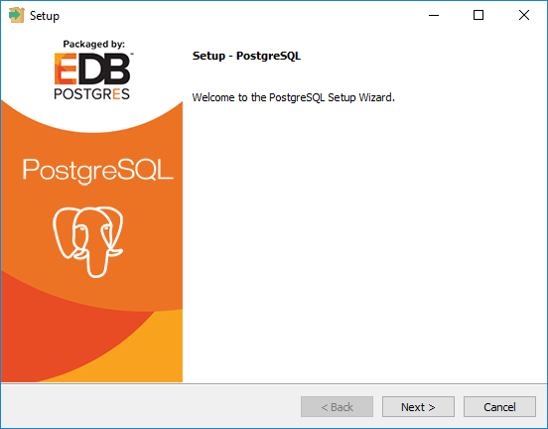

1. Click the Next button

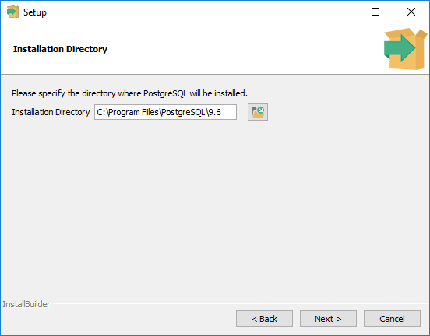

1. Select the installation directory, click the Next button

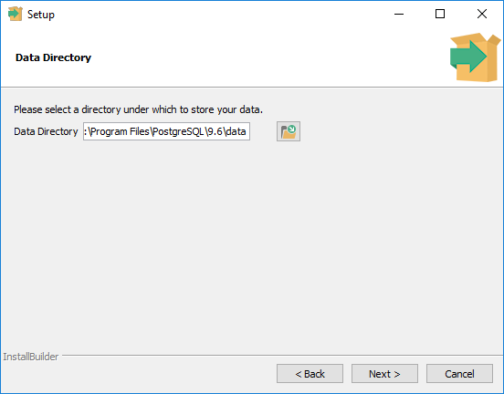

1. Select the data directory, click the Next button

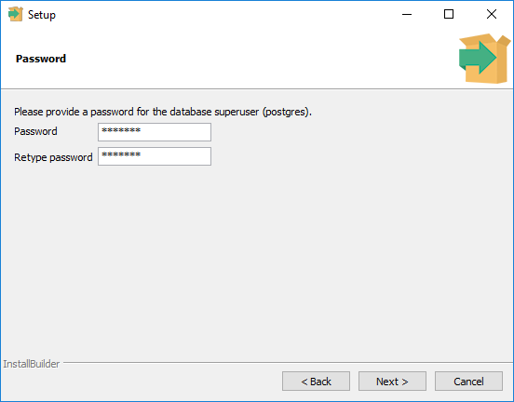

1. Enter password “cop3330” in both text boxes, click the Next button. Please **use lower case letters**, it will make a difference for the associated assignment.

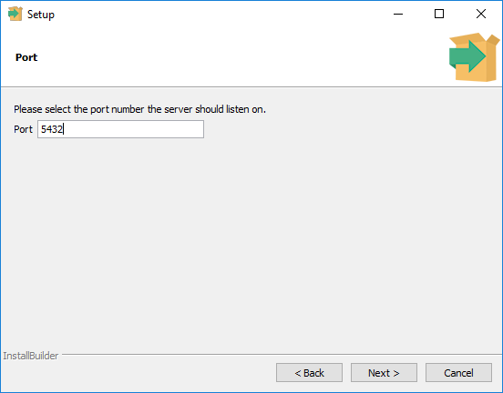

1. Port should be “5432”, click the Next

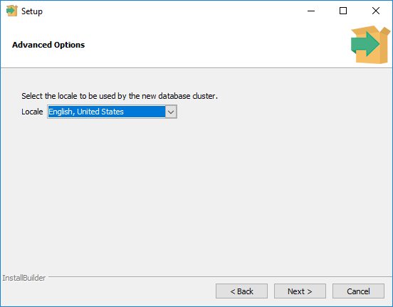

1. 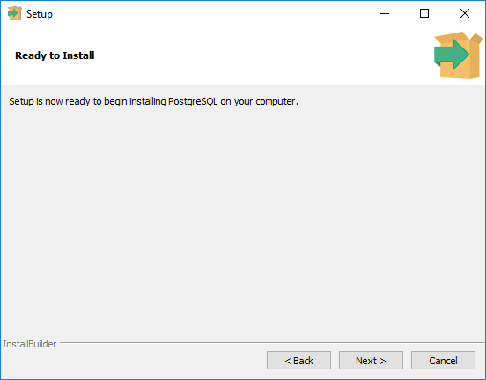Locale, select “English, United State” click the Next

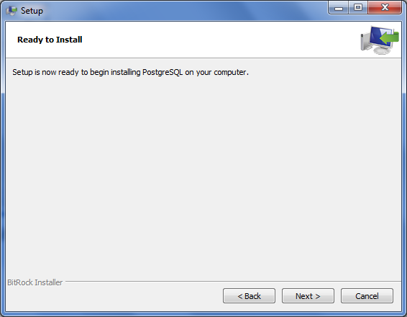

1. Click the Next button

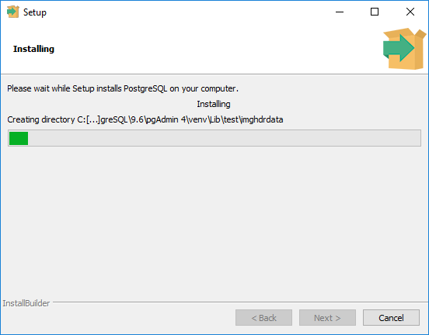

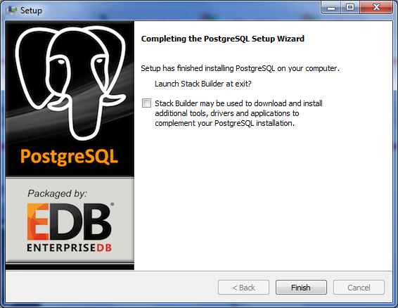

1. Uncheck the check box, click the Finish